Ramblings week 240
Well that is a good number – 240 – 24x 10 – or 2 x 2 x 2 x 2 x3 x5 – It is the product of prime numbers – and not just any prime numbers – just the first 3. The Bible plays with numbers – we have entered the time of Lent – 40 days in the wilderness – and this of course mirrors the 40 years of the Israelite wanderings after the escape from Egypt and the Pharaoh. But numbers go further than just this.
The first number is that of ONE – One God – the unity of God – Monotheism – The Trinitarian theology of course has the 3 in 1 concept – Father, Son and Holy Spirit in a unifying whole. I like the Celtic symbol – the Triquetra
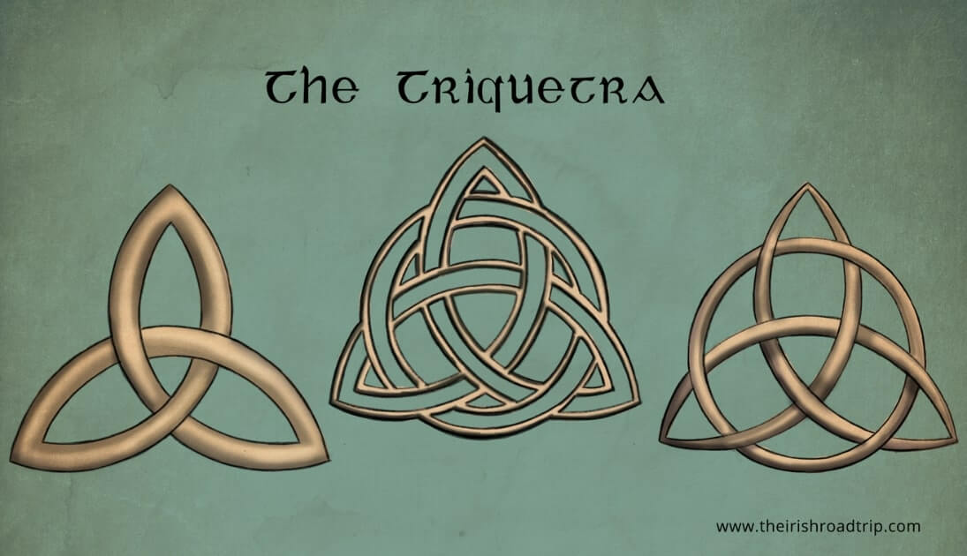
The Triquetra is one of a large number of Celtic symbols that were used by the Celts, an Indo-European people that were defined by their use of Celtic languages. It is one of many Celtic Knots that can be found across the globe. The Triquetra is revered for its three interlocking arcs and the symbol has different meanings depending on the interpreter: for Celts, the life cycle (life, death, rebirth); for Wiccans, the triple goddess (Maiden, Mother, Crone); for Pagans, the three realms (land, sea, sky); and for Christians, a means to convey the Holy Trinity. But what I like is the sense that as we try to integrate the three corners, which I see as the ultimate definition of each personality of the Trinity – the less certain we can be of where we are within the pattern, and yet, with the circle [? the crown of thorns?] we find a unity. For the mathematically inclined, there is all sorts of symmetry – line, rotational and mirror symmetry are all present. Both parts of the Triquetra – the triangular shape and the circular shape – have the sense of eternity, since once started travelling along the shape, the journey has no end – only by leaving the shape does one escape.
Monotheism is contained within the understanding of Yahweh – the intensely personal divine relationship. When Moses goes looking at the bush that burned yet did not burn, he entered into the Revelation of the Divine Name – I AM WHO I AM – I AM reality – which is what John picks up on his gospel – I AM the Good Shepherd – I AM the Way and so on. Ego Emi in the Greek – strictly the translation should be ‘I’ I AM – for Emi means I AM, and the Ego shouts the ‘I’ out with great emphasis – and our translations sadly missed this out – But this unity is not like three parts that slot together – rather more like making pancakes where we have the flour [Father] – the Egg [the Son] and the Milk [the holy Spirit – but when mixed together and cooked – where is the milk or egg or flour? I our Systematic Theology, so beloved of the academic, we seek to filter out the Father bits, the Son bits and Holy Spirit bits – we talk of gifts of the spirit, but are they not gifts of divinity? We talk of Christology but the crucified Christ is not a lone entity surely? The elderly gentleman with long beard sitting on cloud 7 is not a fatherly figure alone and unattended? Like Moses, our faces become ‘sunburned’ as we see the Glory of God which actually hides from our eyes the full person of the Trinity!
We have the number two – the couple – the wedding – For here we have the two people – maybe two rings – but by words and vows and exchange – the two become one the individuals promise that – for better or for worse – they shall be one – When Jesus sends out the disciples they went two by two – just as the animals into the Ark – There were two tablets of stone that the 10 commandments were inscribed upon, For evidence there must be two witnesses – then we have light and darkness – good and evil – life and death – rich and poor – young and old – left and right – big and small –
Then we are at the number 3 – the Trinity number – the triangular shape of the Pyramids – the Third Day, the day of resurrection – but then the 3rd hour is 9 am – time of the morning sacrifice – the time of Jesus’ crucifixion – the time of the rushing wind that filled the house along with ‘tongues of fire’ of the first Pentecost. On the Road to Emmaus, there were firstly two, then three travellers. Peter denied Christ three times, to be asked later three times ‘Do you love Me’. The three Patriarchs – Abraham, Isaac and Jacob – and so on.
We come to 5 [4 is not a Prime number!] – the first 5 books of the Bible, known as the Books of Moses or the Pentateuch – The Tabernacle had 5 curtains, 5 pillars and a 5-cubit altar. In Leviticus, there are five types of offerings (burnt, grain, peace, sin, and guilt). 5 loaves helped feed the 5000
So number 7 – the number signifying perfection – Creation and the seven days – In John the seven “I AM’s” – Peter told to forgive “seven times seventy” – Matthew has seven parables and seven ‘Woes’ – In Revelation, the number 7 is used there more than fifty times in a variety of contexts: there are seven letters to seven churches in Asia and seven spirits before God’s throne, seven golden lampstands, seven stars in Christ’s right hand, seven seals of God’s judgment, seven angels with seven trumpets and so on. I find it interesting that an ideal size for a leadership group is often around the seven number –
Of course we could continue- even to having pages and pages on the meaning of the number 666 [or should it be 999?]. As I live very near to the A666 with its delays, traffic jams, traffic lights and not infrequently, holes in the road, I do not wish to ffend it least it seeks vengeance upon myself!!
So the number 40 - It signifies a period of testing, trial, probation, and spiritual preparation or transformation, appearing over 150 times in the Bible. It often represents a waiting period that leads to a new beginning, such as the 40 days of rain in Noah's flood, 40 years of wilderness wandering, or 40 days of Jesus' fasting. Moses spent 40 days on Mount Sinai (Exodus 24:18) The flood lasted 40 days (Genesis 7:4), and Jonah warned that Nineveh would be destroyed in 40 days. Moses lived 40 years in Egypt and 40 years in the desert. David and Solomon both reigned for 40 years. Jesus appeared to disciples for 40 days before ascending (Acts 1:3). In Hebrew tradition, 40 represents a transition or renewal.
Google AI tells me
“ In the Bible, age 80 represents a milestone of seasoned strength, wisdom, and continued purpose, notably marking when Moses began leading the Exodus. Psalm 90:10 defines 80 as a "ripe old age" achieved through strength. It is associated with significant leadership, divine service, and the continued, valuable contribution of the elderly
Psalm 90 v 10 - Our days may come to seventy years, or eighty, if our strength endures;
yet the best of them are but trouble and sorrow, for they quickly pass, and we fly away. ¹¹ If only we knew the power of your anger! Your wrath is as great as the fear that is your due.
¹² Teach us to number our days, that we may gain a heart of wisdom.
As the sight of the age of 80 grows slowly closer, yes I need to count my days – yes number them and have that deep sense of gratitude that each day as I awake, I have a purpose for this gift of life. Lent is not a time to give this up, but rather take up the warmth of being Love with overwhelming love.

